Упр1.
Use the correct form of the verbs in Past Indefinite.
- The children ……… (gather) around their teacher after classes.
- We…….. (buy) two big bright balloons when we were in the park.
- The story ……. (be) funny and everybody …….. (laugh).
- Helen …… (decorate) the walls of her room with pictures.
- Bill’s friends ……..( sing) Happy Birthday! Then they ……( give) him presents.
- It …….(be) very dark in the room and we ……. (see) nothing.
- Mary …………( send) bright postcards to her friends at Christmastime.
- Mother …………..(decorate) the birthday cake with small chocolates.
- The boy ……… ( spend) all the afternoon at the stadium.
- We …..( get) very nice Christmas cards from our friends.
Упр.2
Ask questions for more information.
- Tom spent a lot of time indoors. (When?)
- She guessed the answer at once. ( Who?)
- They got presents from their parents and friends. ( When?)
- Bill brought a puppet to school. ( Why?)
- Kim’s sister tried to teach her some tricks.(What tricks?)
- Jane sang a song at the concert.(Why?)

TOO * ALSO
Ann speaks good English. Use also before the verb.
She can also speak French. (Ставим also перед глаголом)

My grandparents came to wish a happy birthday to me. All my friends came too.
Use too at the end of the sentence.
(Ставим too в конце предложения)

Упр.3
Too? Also? Use the correct word.
- Tom went to the circus last Sunday. His friend Bob was at the circus ……….. .
- Jane and Ann were at the party. Kate was there ……. . Some of their classmates were ….. at the party.
- My sister likes watching films on television. I ……… Like to watch TV.
- Jane laughed and her guests laughed ……. .
- Did you ……… go to the circus to see a new show.

Prepositions
Упр.4
Use the correct prepositions from the list: at, to, with, on.
- The children were laughing …….. the clown who was doing funny tricks.
- They are …… the party now.
- How often did you go ……. the circus last year?
- What are you laughing ………, boys?
- The first of April is the day of fun when people play jokes ……. Each other.
- They decorated the hall ……. Balloons.

SOME * SOMETHING * SOMEBODY
There are some nice presents in the Christmas stocking.
Mother cooked something very tasty for the holiday dinner.
I can ask somebody to go shopping with me.

ANY * ANYTHING * ANYBODY
Is there any shop near your house? I want to buy some fruit.
We did not know anything about his letters. It was a surprise.
Is there anybody who can help me to carry a Christmas tree?
NO * NOTHING * NOBODY
There is no book more interesting than Tom Sawyer, I think.
To their surprise, they saw nobody in the room.
There is nothing interesting on TV today. I think it is better to read a book.

Упр.5
Some? Something? Somebody?
- There are …….. children playing in the snow in the park.
- …………… telephoned me in the morning but I was out.
- I saw ……… bright near the tree but could not guess what it was.
Any? Anything? Anybody?
- Did you make …….. wish for the New Year?
- Is there ……… here who knows how to play this game?
- The boy did not say …………, he only laughed.
No? Nothing? Nobody?
- There were a lot of different fruit on the table but there were ………. Bananas.
- ………….. knows what the new film is about.
- We opened the box. There was …….. in it.
Упр.6
Complete the dialogues with ANY, ANYTHING, NO, NOTHING
- Is there …….. interesting on television this evening?
- No, there is ………… interesting at all.

- Are there ……… new boys and girls at the party?
- No, there are ………. new people. There are only those whom we know well.

- Show me some of your drawings, please,
- Sorry, I have not got ……. at the moment.

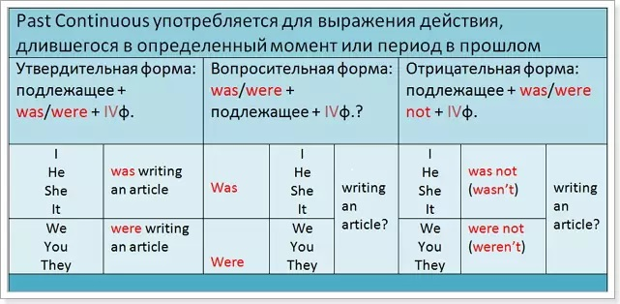

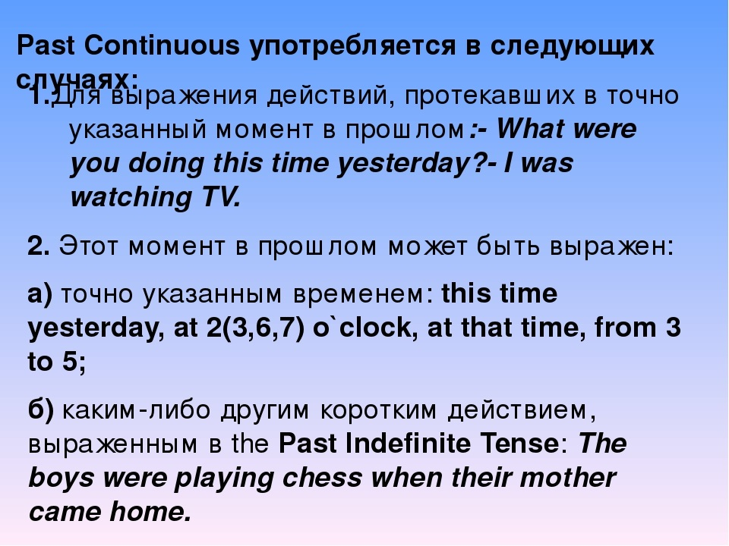

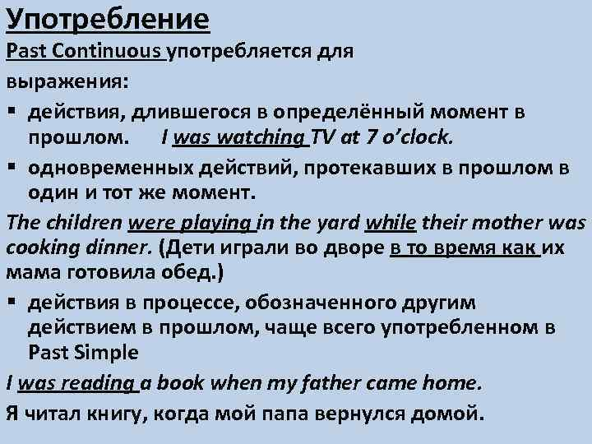

Упр.7
Read three texts and say:
What were the animals doing?
1) It rained very hard yesterday. The water ran down the hill by our house. We did not see our pet dog anywhere. Where do you think we found him? He was sitting in a big pool of rain water.

2) Last Saturday my elder brother Dave and I went to the zoo. The first animals we saw were large cats. Dave said those were a leopard, a tiger, and a jaguar. Then we saw a monkey. It was sitting in a tree. The monkey was eating a banana. The tallest animal we saw was a giraffe. It was eating leaves from the tops of trees. What a fine day! I hope we can go to the zoo again.

3) Yesterday I looked out of the window, and what do you think I saw? I saw a rabbit. It was eating our lettuce in the garden.
And I saw an elephant. Yes, I did - a real elephant. He was coming out of the garage and he was so big he couldn’t even get through the door.
And I saw a bug. I don’t Know its name but it was a black bug. It was flying with a funny noise.
And I saw a little robin with a piece of grass in its beak. I thought he was building a nest with it.
And I saw a very big fish. It was splashing in the pond. Maybe it was not a whale but it was as big as a whale. If it was not a whale it was almost a whale.
And I saw a kitten up a tree. She was sitting on a branch. She did not know how to come down. So she was crying: Meow!Meow! Poor little kitten! I took a ladder and helped her down.

- The rabbit ……
- The bug ……….
- The dog ……….
- …………………….
- ……………………..

