Перевести и выучить!
Словарь:
Begin (began)- Autumn begins at September
Dark- a dark night, dark clouds. There were dark clouds in the sky.
Light- Summer evenings are light, but winter evenings are dark.
Fresh-It was a fresh spring morning.
Air- fresh air. The air is fresh after rain.
Ground- on the ground. There are lots of bright leaves on the ground in autumn. The ground is white in winter.
Become(became)- Leaves become green in spring. The weather became warmer.
Get(got)- to get cold, to get warm. The Days were getting shorter. It was getting colder. What time does it get dark in summer?
Fall(fell)- the leaves are falling down. Snow began to fall.
Fly(flew)- not all birds fly away to warm countries in autumn.
Blow(blew)- soon a cold wind began to blow. I don’t like it when the wind is blowing.
Wet- to get wet. It was raining and we all got wet. The weather was cold and wet. Why are your clothes so wet?
Dry- dry weather. The air was hot and dry.
During- during the long winter months. The wind blue strong during the storm. It rained during the night.
Around- look around! It is so beautiful here. There are so many interesting things around.
Light- come in to the light where I can see you.
Frost- the first frosts of autumn. There were a lot of frosts this year. There was a frost last night. The frost became stronger and stronger.
Fog- winter brought the fogs. I can not see anything in this fog.
Storm- the storm brought much wind and rain.
Ice- I like to put ice into my orange juice to make it colder. Her hands were as cold as ice.
Thick- thick ice, thick clouds, thick forests. The trees were thick and the forest was dark. There was a frost last night and the ice on the lake became thick.
Thin- It is cold but she is wearing a thin summer jacket.
Indoors- come indoors , it is cold.
Outdoors- when the weather is good, we play outdoors. Shall we play indoors or outdoors?
Wonderful- a wonderful day, to have a wonderful time. It was wonderful to spend a dae in the park.
Terrible- terrible weather, a terrible winter day. What a terrible day! What terrible weather!
Suddenly- the sky suddenly became dark. It suddenly began to rain.

Фразы
pick leaves in the forest
play snowballs
Wear winter (spring, autumn) clothes
Play with small paper boats
Have hats (scarfs, jackets) on
Have a good time
The bright sun
Give food to baby birds
Baby birds in the nest
Make a nest
Get colder(warm)
Be fun
Play in the dry autumn leaves
Sunny day, warm weather
Be of different colours
Bright leaves on the ground
Grey sky, thick dark clouds
Strong wind
Windy weather, terrible weather
Wet ground
Rainy day,
Be cold
Rain during the whole day

Письменные упражнения:
1.Compare different seasons. Say in what seasons:
The weather becomes warmer/colder
The grass becomes green/dry
It gets hot/cold
The sky gets dark/ light
Evenings are dark/ light
Birds begin to make their nests/fly away to warm countries
Leaves begin to fall down from the trees/become green
The ground is often wet/dry
The sky is usually blue/grey
2.Compare different seasons and months of the year.
When is the sun brighter, in summer or in autumn?
When are flowers more beautiful, in Aptil or in June?
When can children have a better time outdoors, in summer or in winter?
When is the sky darker, in late spring or in late autumn?
When are the days colder, in autumn or in winter?
When is the nature more colourful, in September or in November?
When is the better(worse)to go travelling, in July or in February?
3.Talk about each season of the year. What interesting things can you see in each season?

The world around you
The world is full of wonderful things. You see the blue sky and the grey rain, the black night and the shiny stars, trees and mountains, seas and sunshine. These things are the world, and they are all around you.
Do you know why we need the sun? Why the moon is bright? What animals live on the Earth? Why the stars look very small? It is fun to know more about the world around you.
The world we live on is a big, big round ball. It is turning all the time, but you can not see or feel it. There are other worlds too, but the one we live on is the Earth. The Sun shines on the Earth, the rains fall on it, the wind blows on it.
There is more water on the Earth than anything else, more water than land, forest or grass. Some water falls to the Earth as rain. Some of the water is in rivers. Some water is in lakes. And some is in the deep oceans, this water is salty. But there is water not only in rivers and oceans and lakes. Water is in trees, flowers, and in the air, and there is a lot of water in you. Nothing can live without water.
The Sun gives more light than all the electric lights in the world. It keeps the Earth warm. Without sunshine nothing will grow in the world.
At night you can see the stars. All day the stars are in the sky, but the light from the Sun is so bright, you can not see them. The stars are bright only in the dark sky.
Stars look very, very small, but some are bigger than the Sun. Big things look little when they are far away. In the sky, airplanes look like toys, but on the ground you can see that they are very big.
The Moon is ball, too, like the Earth and the Sun. It is smaller than the stars, but it is nearer, so it looks bigger. The moon has no light. It is bright because the Sun shines on it.
Answer the Questions
- Can you see and feel that our Earth is turning all the time?
- Why do we need the Sun? Can plants grow without sunshine?
- Where can we find water on the Earth? Is there any water in the air?
- Why can we see stars only at night ? Why do stars look very small?
- Which is smaller, the Moon or the stars? Why is the Moon bright?
- What wonderful things can you see around you?

Образование прилагательных из существительных
Noun+ -y = adjectives
Rain-rainy | Storm- stormy | Fog-foggy
Cloud- cloudy | Frost-frosty | Sun-sunny
March days are……………………….. (wind).
Yesterday the sky was……………….(cloud).
We all like ………………………………(sun) days.
It is fun to play on …………………..(snow) days.
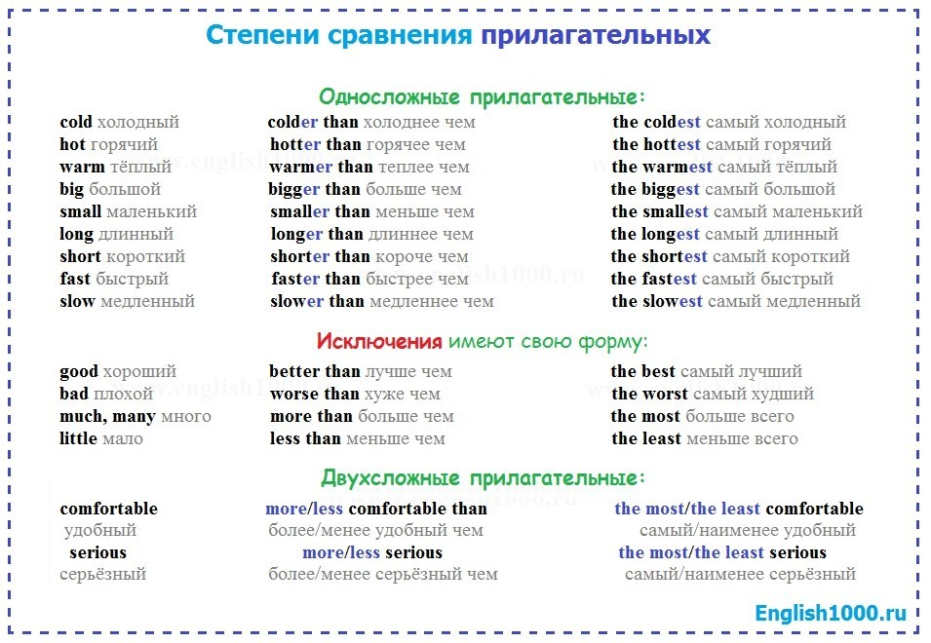

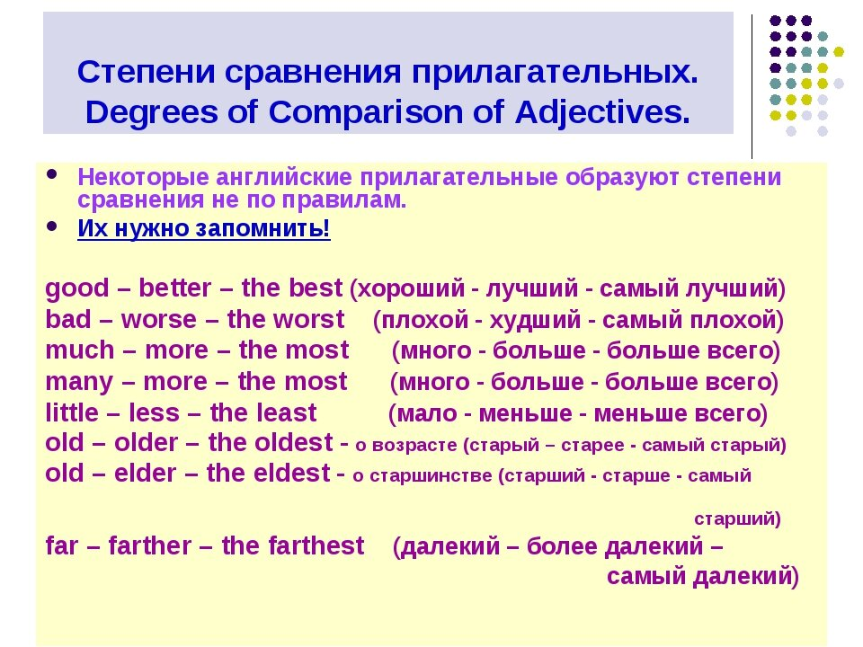

Упражнения( письменно):
Comparative? Superlative?
Kate thinks roses are ……………………………………………(beautiful) flower.
Bill is ……………………………..(serious) boy in his class.
John is …………………………… (serious)than some of his classmates.
Forests are ………………………………………..(beautiful) in May than in April.
Michael thinks that detective stories are …………………………(interesting) to read than tales.
Your summer clothes are …………………………(colourful) than the clothes that you wear in autumn.
Books about nature are …………………………..(interesting) of all, I think.
Boys are often ……………………………….(noisy) than girls.
Fresh vegetables are ……………….(good) for you.
She thinks that early spring is ………………… (good) time of the year.
The weather was ………………(bad) than usual, it rained and rained.

